**Project Report Template**

1. **INTRODUCTION**

1.1 Overview

It is to show the people about your content and summary of your channel so that your channel will grow according to your thoughts relating the content.

1.2 Purpose

The purpose of top youtube channels is to entertain the people who all are following their contents and fulfill the needs of the people by uploading contents related to their needs.

**2 PROBLEM DEFINITION & DESIGN THINKING**

2.1 Empathy map

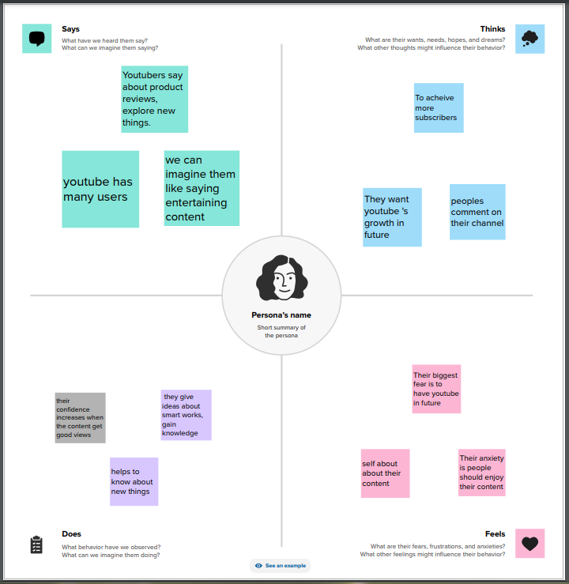

2.2 Brainstroming map

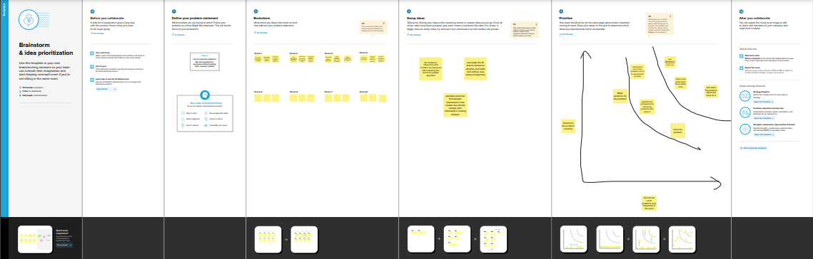

**3 RESULT**

Dashboard 1

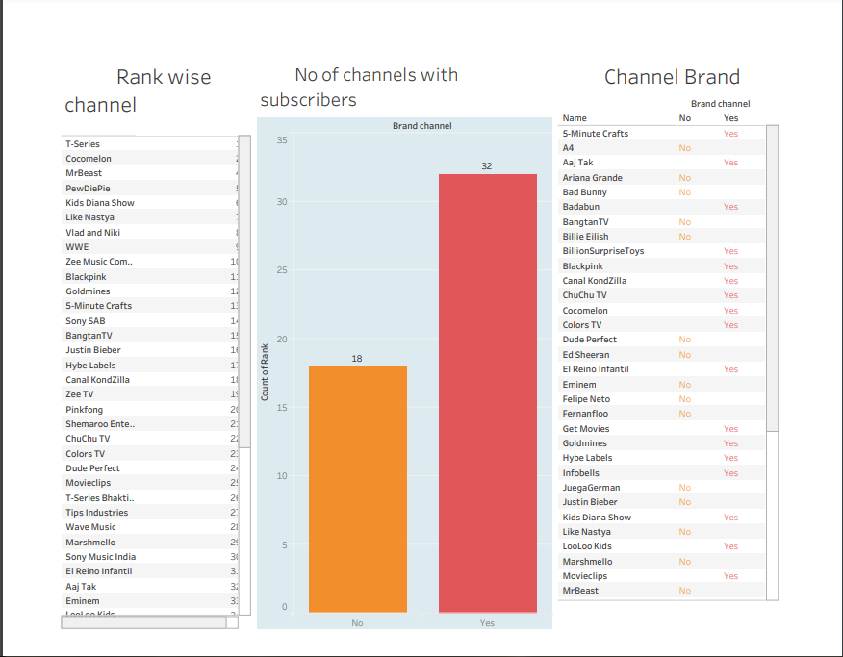

Dashboard 2

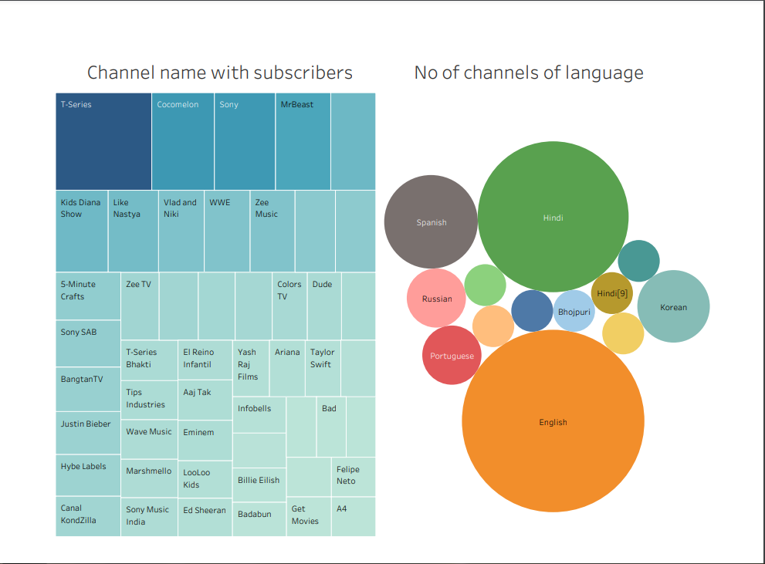

Dashboard 3

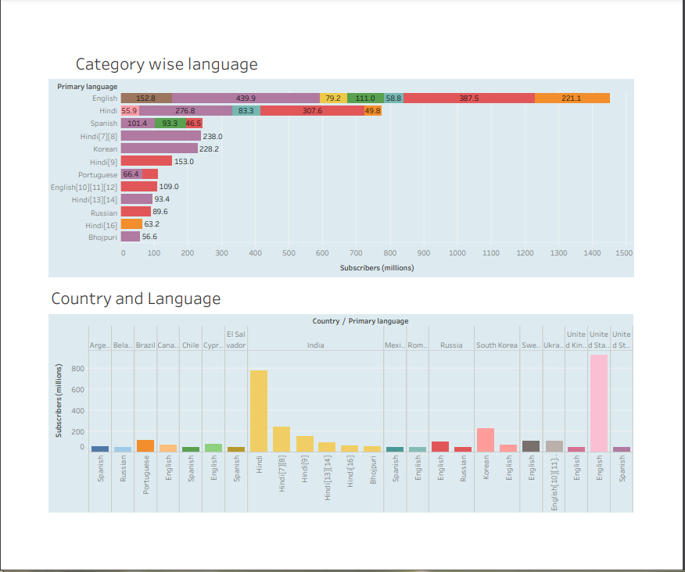

Dashboard 4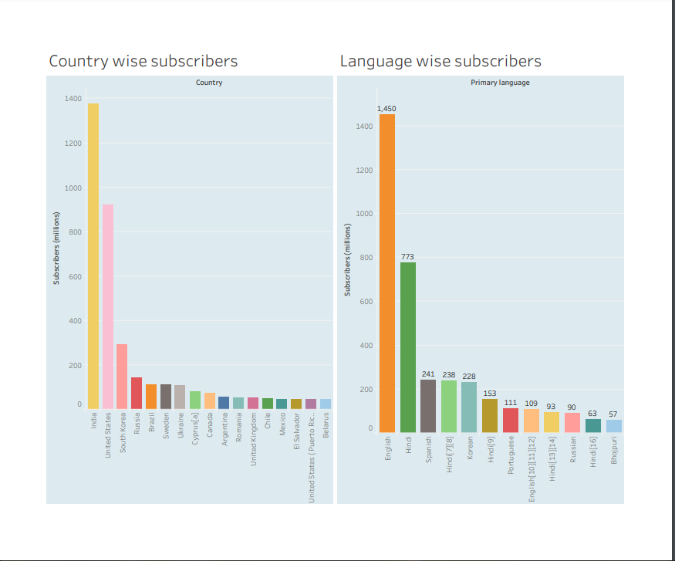

Dashboard 5

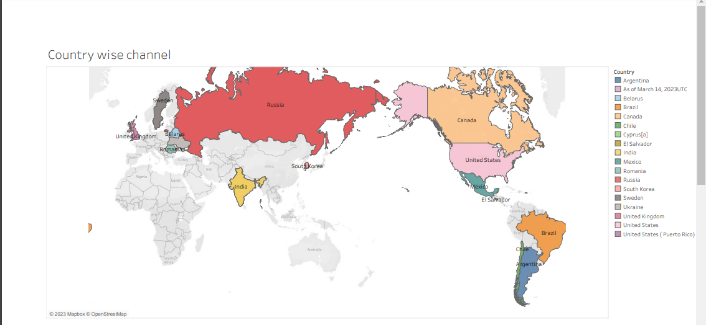

Story

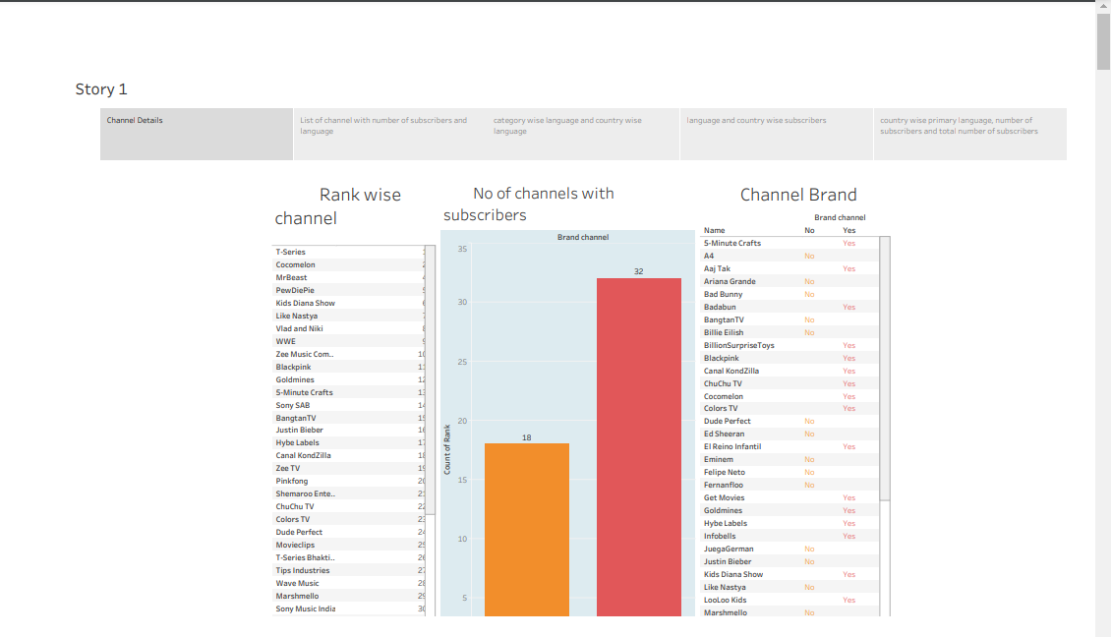

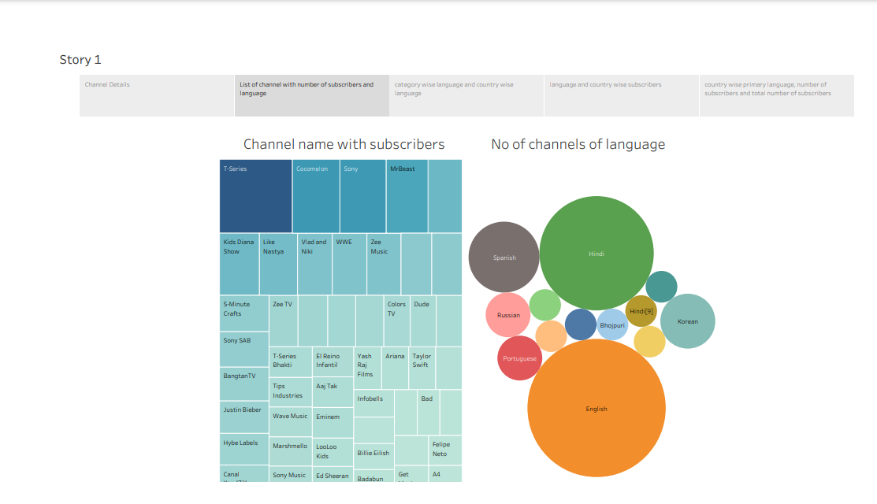

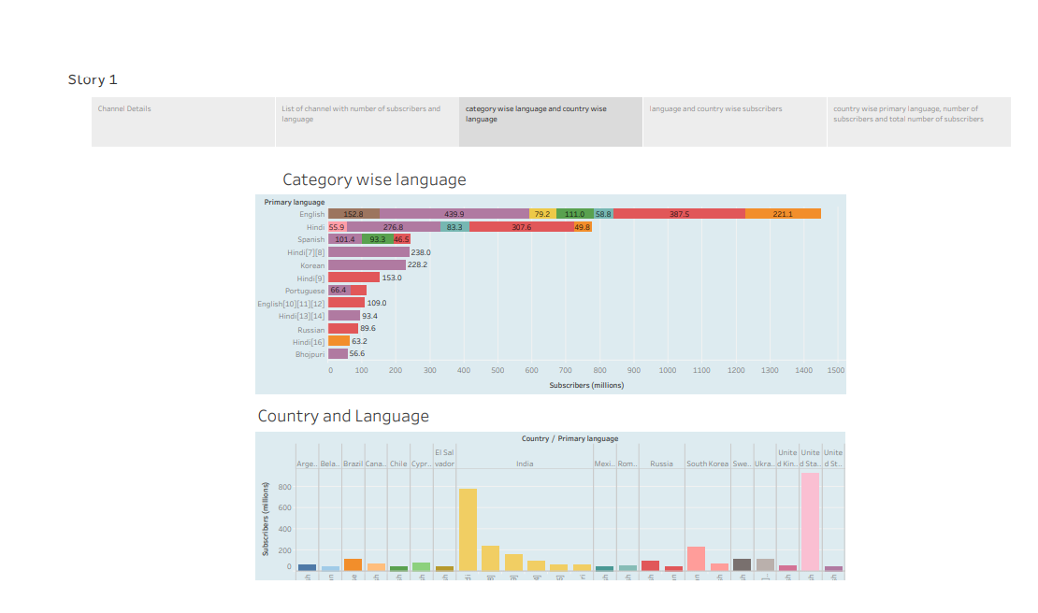

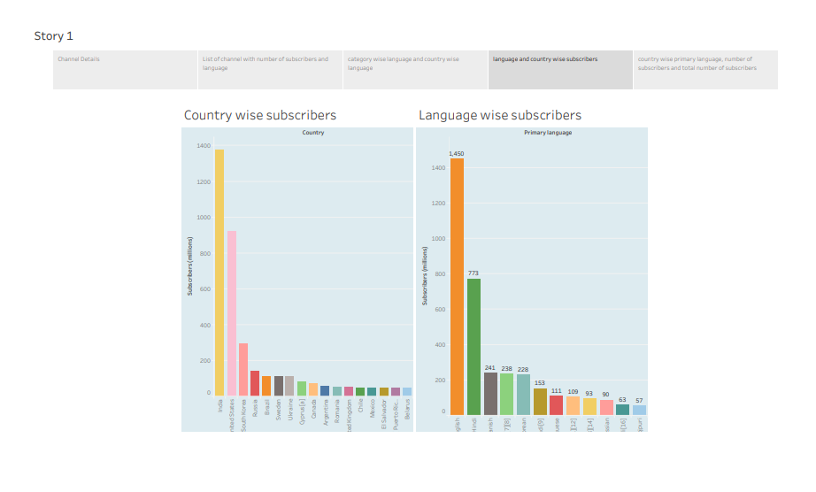

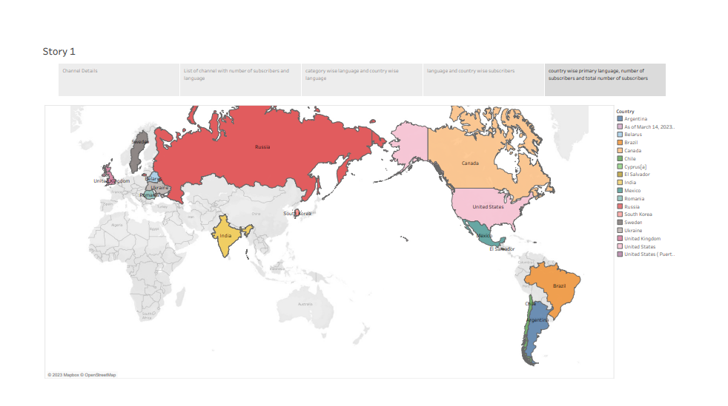

**4** **ADVANTAGES & DISADVANTAGES**

*Advantage*: Youtube is a free learning platform to understand our needs . There will be many videos relating our doubts so that we can learn many ideas and the creator can earn from his content based on youtube statistics.

*Dis Advantage*: Since anyone can upload videos in youtube, the quality of the content on the platform can be very variable. This can make it difficult to find high quality, reliable information or entertainment. Not every content is good and It also increases screen time and very dangerous for eyes.

**5 APPLICATION**

We wish to change is the treatment from youtube toward unpopular youtuber and monetization rule revision to participate in youtube program and try to adjust the metrics to promote quality over quantity.

**6 CONCLUSION**

Youtube is a free learning platform and it helps to gain more ideas what people want to know. Based on people’s favourites content , the views will increase so that a creator should analyze people favourites and try to make videos in a attracive way and different from other contents.

**7 FUTURE SCOPE**

We know that youtube is growing very much better. The rise of short form videos, personalized content and recommendation , interactive and shoppable videos, virtual and augumented reality experiences, influencer marketing evolution. The evolution of youtube in future will be more influential and high demand video destination allow the viewers to have a more active role in show creation.